**CONVOLUTION**

**LAB # 08**



**Spring 2022**

**CSE301L Signals & Systems Lab**

Submitted by: **Ebtihaj Abdullah**

Registration No. : **20PWCSE1885**

Class Section: **A**

“On my honor, as student of University of Engineering and Technology, I have neither given nor received unauthorized assistance on this academic work.”

Student Signature: ______________

Submitted to:

**Engr. Durr-e-Nayab**

Wednesday, June 25, 2022

**Department of Computer Systems Engineering**

**University of Engineering and Technology, Peshawar**

## Lab Objective(s):

Objectives of this Lab are;

* Making Signals Causal and Non‐Causal
* Convolution
* Properties of Convolution

## Task # 01,02:

1. Sample the signal given in above example to get its discrete‐time counterpart (take 10 samples/sec as sampling rate). Make the resultant signal causal. Display the lollipop plot of each signal.
2. A signal is said to be anti‐causal if it exists for values of n<0. Make the signal given in above example anti‐causal

**Problem Analysis:**

We can perform different operations of signals in MATLAB. Here we make a causal signal than change its causality.

**Algorithm:**

* Write the code
* Execute it
* Observe the output

**Code:**

*t=-1:1/1000:1;*

*f=3;*

*A=5;*

*s=A*cos(2*pi*f*t);*

*subplot(2,2,1);*

*plot(t,s);*

*u = (t>=0);*

*s1=s.*u;*

*subplot(2,2,2);*

*plot(u);*

*subplot(2,2,3);*

*plot(s1);*

*u1=(t<=0);*

*s2=s.*u1;*

*subplot(2,2,4);*

*plot(s2);*

**Output / Graphs / Plots / Results:**

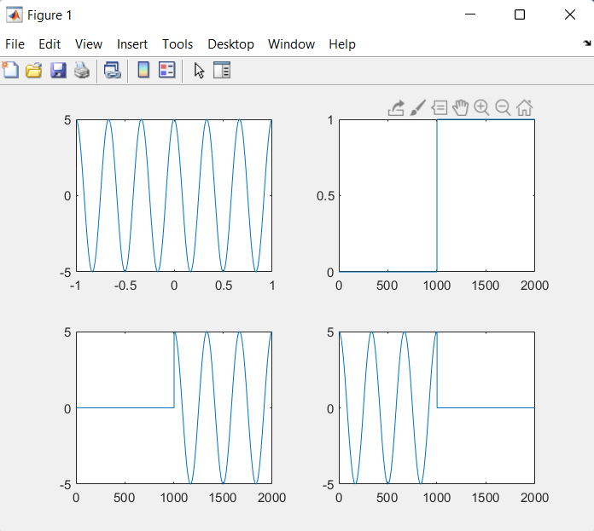

**Discussion and Conclusion:**

We can perform different operations of signals in MATLAB.

## Task # 03:

Create a function by name of sig_causal in matlab that has two input arguments: (i) a discrete‐time

signal, and (ii) a position vector. The function should make the given signal causal and return the

resultant signal to the calling program.

**Problem Analysis:**

We can perform different operations of signals in MATLAB. Here we make a causal signal than change its causality.

**Algorithm:**

* Write the code
* Execute it
* Observe the output

**Code:**

*function [sig1]=sig_causal(sig,v)*

*t=[1:length(sig)];*

*u=(t>v);*

*sig1=sig.*u;*

*return*

**Output / Graphs / Plots / Results:**

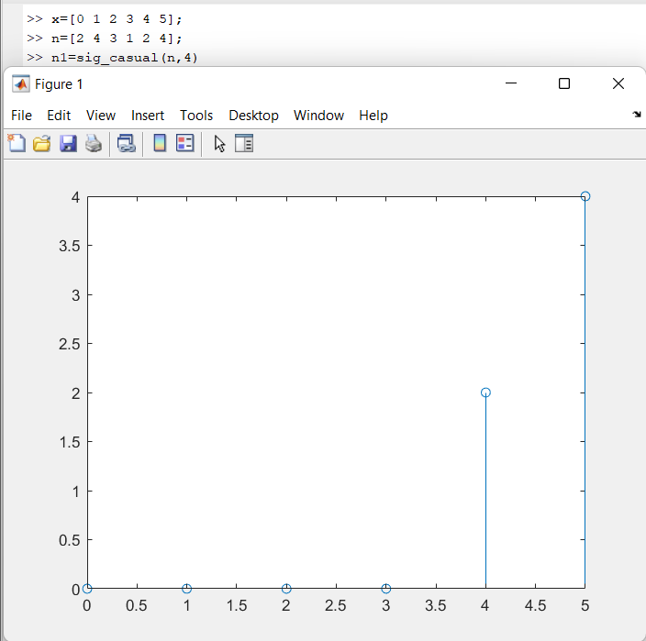

**Discussion and Conclusion:**

We can perform different operations of signals in MATLAB.

## Task # 04:

Convolve the following

signals: x =[2 4 6 4 2];

h =[3 ‐1 2 1];

Plot the input signal as well as the output signal.

**Problem Analysis:**

We can perform different operations of signals in MATLAB. We perform Convolution in MATLAB.

**Algorithm:**

* Write the code
* Execute it
* Observe the output

**Code:**

*x=[2 4 6 4 2];*

*h=[3 -1 2 1];*

*y=conv(x,h);*

*n=[1 2 3 4 5];*

*subplot(2,1,1);*

*stem(n,x);*

*subplot(2,1,2);*

*stem(y);*

**Output / Graphs / Plots / Results:**

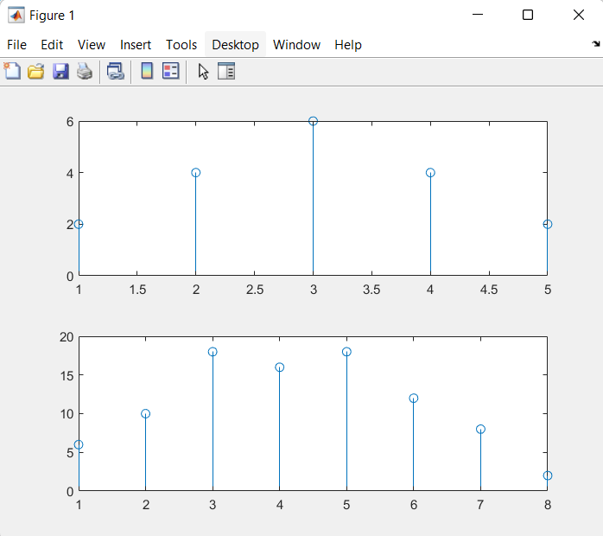

**Discussion and Conclusion:**

We can perform different operations of signals in MATLAB.

## Task # 05:

Convolution is associative. Given the three signal x1[n], x2[n], and x3[n]

As: x1[n]= [3 1 1]

x2[n]= [4 2 1]

x3[n]=[3 2 1 2 3]

Show that (x1[n] * x2[n]) * x3[n] = x1[n] * (x2[n] * x3[n]).

**Problem Analysis:**

We can perform different operations of signals in MATLAB. We perform Convolution in MATLAB.

**Algorithm:**

* Write the code
* Execute it
* Observe the output

**Code:**

*x1=[3 1 1];*

*x2=[4 2 1];*

*x3=[3 2 1 2 3];*

*z1=conv(x1,x2);*

*z2=conv(z1,x3);*

*z3=conv(x2,x3);*

*z4=conv(z3,x1);*

*subplot(2,1,1);*

*stem(z1);*

*subplot(2,1,2);*

*stem(z2);*

**Output / Graphs / Plots / Results:**

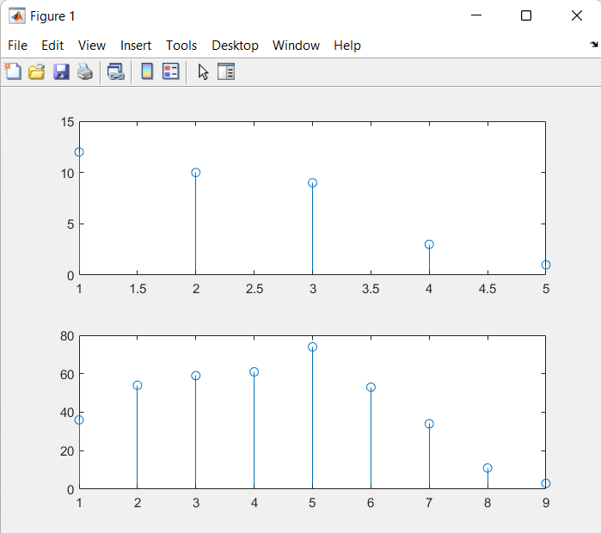

**Discussion and Conclusion:**

We can perform different operations of signals in MATLAB.

## Task # 06:

Convolution is commutative. Given x[n] and h[n] as:

X[n]=[1 3 2 1]

H[n]=[1 1 2]

Show that x[n] * h[n] = h[n] * x[n].

**Problem Analysis:**

We can perform different operations of signals in MATLAB. We perform Convolution in MATLAB.

**Algorithm:**

* Write the code
* Execute it
* Observe the output

**Code:**

*x=[1 3 2 1];*

*h=[1 1 2];*

*z1= conv(x,h);*

*subplot(2,1,1);*

*plot(z1);*

*z2= conv(h,x);*

*subplot(2,1,2);*

*plot(z2);*

**Output / Graphs / Plots / Results:**

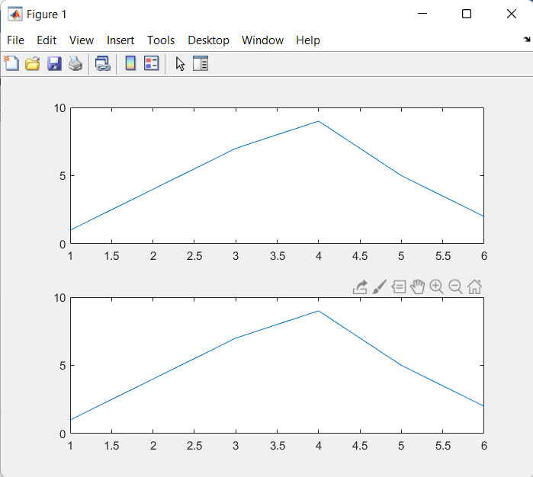

**Discussion and Conclusion:**

We can perform different operations of signals in MATLAB.

## Task # 07:

Given the impulse response of the systems as:

h[n]= 2δ[n] + δ[n‐1]+ 2δ[n‐2]+ 4δ[n‐3]+ 3δ[n‐4]

If the input x[n] = δ[n]+ 4δ[n‐1] +3δ[n‐2] + 2δ[n‐3] is applied to the system, determine the output of

the system.

**Problem Analysis:**

We can perform different operations of signals in MATLAB. We perform Convolution in MATLAB.

**Algorithm:**

* Write the code
* Execute it
* Observe the output

**Code:**

*h=[2 1 2 4 3];*

*x=[1 4 3 2];*

*z=conv(h,x);*

*plot(z);*

**Output / Graphs / Plots / Results:**

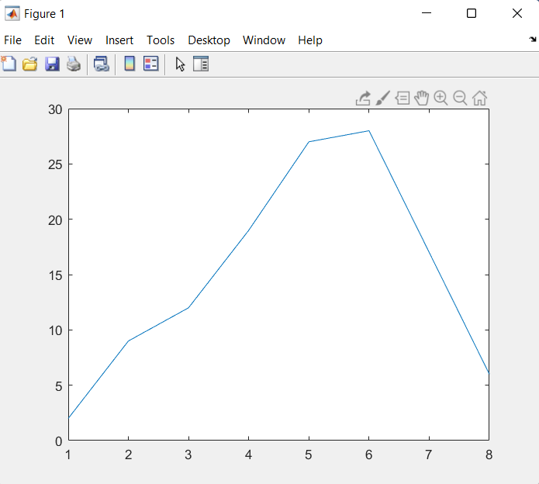

**Discussion and Conclusion:**

We can perform different operations of signals in MATLAB.

## Task # 08:

Two systems are connected in cascade:

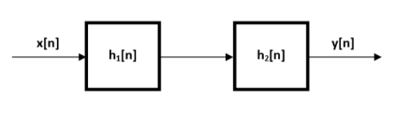

h1[n]=[1 3 2 1]

h2[n]=[1 1 2]

If the input x[n] = δ[n]+ 4δ[n‐1] +3δ[n‐2] +2δ[n‐3] is applied, determine the output.

**Problem Analysis:**

We can perform different operations of signals in MATLAB. We perform Convolution in MATLAB.

**Algorithm:**

* Write the code
* Execute it
* Observe the output

**Code:**

*h1=[1 3 2 1];*

*h2=[1 1 2];*

*x=[1 4 3 2];*

*y=conv(x,h1);*

*z=conv(y,h2);*

*plot(x);*

*plot(z);*

**Output / Graphs / Plots / Results:**

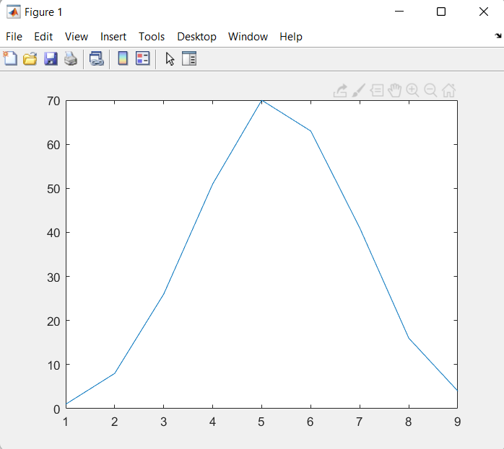

**Discussion and Conclusion:**

We can perform different operations of signals in MATLAB.

## Task # 09:

Given the signals:

x1[n]= 2δ[n] ‐3δ[n‐1]+ 3δ[n‐2] +4δ[n‐3] ‐2δ[n‐4]

x2[n]= 4δ[n]+ 2δ[n‐1]+ 3δ[n‐2] ‐ δ[n‐3] ‐2δ[n‐4]

x3[n]= 3δ[n]+ 5δ[n‐1]‐3δ[n‐2] +4 δ[n‐3]

Verify that

x1[n] * (x2[n] * x3[n]) = (x1[n] * x2[n]) * x3[n]

**Problem Analysis:**

We can perform different operations of signals in MATLAB. We perform Convolution in MATLAB.

**Algorithm:**

* Write the code
* Execute it
* Observe the output

**Code:**

*x1=[2 -3 3 4 -2];*

*x2=[ 2 3 -1 -2];*

*x3=[3 5 -3 4];*

*y1=conv(x2,x3);*

*y2=conv(y1,x1);*

*z1=conv(x1,x2);*

*z2=conv(z1,x3);*

*figure(1)*

*subplot(2,1,1);*

*plot(y2);*

*title('LHS of 1');*

*subplot(2,1,2);*

*plot(z2);*

*title('RHS of 1');*

**Output / Graphs / Plots / Results:**

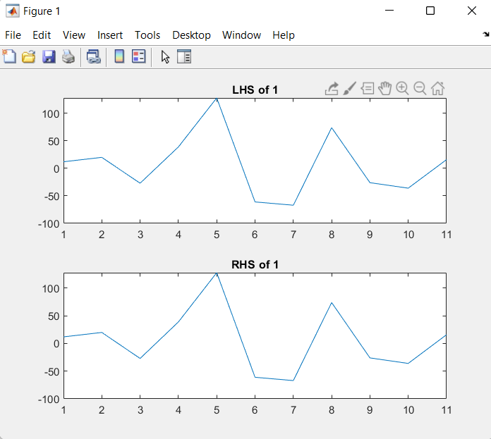

**Discussion and Conclusion:**

We can perform different operations of signals in MATLAB.